

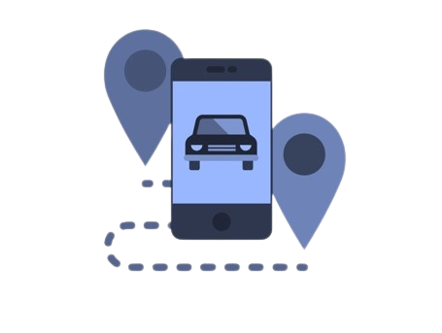

By Hunters

Izzat ALnajjar, Saif Alyan,Hasan Alhwietat, Mahmoud Rummaneh

Contents

I. Team Mission 5

SDGs: 5

technologies 5

why choosing this SDG 5

II. The Challenge 6

challenge statement 6

why this is important 6

Challenge Description 8

customer segment 8

pains of our customer 8

jobs to be done 8

Value Proposition Canvas 9

III. The Solution 9

Describe solution 9

Explain how the solution addresses the challenge 9

Features 10

Benefits 10

describe how your customers currently solve their pain 11

Value Proposition Statement 11

Prototype 11

Describe prototyping plan 11

Describe and present results of your prototyping work 14

IV. Business Model 24

Business Model Canvas 24

Explain blocks in Business Model Canvas 24

aspects of the Business Model 25

Revenue Model 26

explain revenue model 26

V. Market Analysis 27

Where product lunch 27

Market Segment & Size 27

Describe market size 27

Describe market growth 29

market segment and customr persona 29

Expected percentage of som market in the first 3 years 30

Primary Market Research 31

Describe Primary Market Research 31

Secondary Market Research 33

Describe Secondary Market Research 33

Competitive Landscape 34

direct and indirect competitors 34

Different between TAreeq and direct Competitors: - 35

VI. Go-To-Market Strategy 36

Marketing 4 Ps 36

Define Tareeq attributes and benefits 36

Define Pricing strategy 37

Define place (distribution channels) 37

Define Promotion Channels (And cost-related) 38

Branding 39

logo 39

What is the meaning of your logo? 39

What is your main brand’s message? Promise? 39

Go-To-Market Plan 40

Briefly describe your (GTM) marketing Goals 40

Explains the aspects of GTM strategy 40

VII. Financials 41

Cost Structure 41

Initial Start-Up Cost 41

Fixed Cost (Operating expenses) Per Month 41

Variable Cost Per One Unit 41

Include any relevant assumptions here 42

Pricing 42

pricing model and strategy 42

Include pricing for all services and/or products you intend to sell upon launch. 43

Breakeven Analysis 43

break-even point 43

Income Statement 44

Volume projection 44

VIII. Final Statement 47

As team your experience in the bootcamp and working together 47

Highlight insights, important learnings and mindset transformation 48

Leave us with an inspirational last statement 49

Appendices 49

Appendix 1 – Development Work 49

Team Canvas 49

mindmaps 50

Customer journey maps 50

Idea Brainstorming 51

People's opinions about the project 52

pmr data 53

# I. Team Mission

### SDGs:

1. INDUSTRY, INNOVATION AND INFRASTRUCTRE
2. DECENT WORK AND ECONOMIC GROWTH

### technologies

* Mobile application

Due to the world’s orientation to technology, and the world have phones and uses them greatly in their daily lives, so we used mobile application technology because it helps to increase customers, increase sales, brand awareness, provide services to all, increase accessibility, and provide mobile applications ease of use and help customers meet all their needs and requirements in any times

### why choosing this SDG

Jordan in particular is one of the most known countries when it comes to a bad infrastructure, which is why we chose this mission, in the hopes of benefitting our country.

Using the Sustainable Development Goals (SDGs) adopted by the United Nations in 2015 as a global call to action to eradicate poverty, protect the planet and ensure that all people enjoy peace and prosperity by 2030, which follows 17 basic life goals such as ending poverty, good education, etc. We must all strive with them to achieve an ideal life of stability, sustainability and comfort for all. The 2 main reasons we chose these SDGs is because we want to benefit our region in fields where support is lacking, and we aim to create jobs for hundreds of people. While the main mission we want to work with is an infrastructure related one, we also want to give enough attention to economic growth and being sustainable, as Jordan is lacking in these 2 departments as well.

Jordan is one of the countries that are very interested in sustainable development goals, because companies are oriented towards combating the environmental and economic challenges they face, and calls on companies to apply creativity and innovation to solve these challenges. Which is why I think we will face minimal challenges. The Sustainable Development Goals help open up new business opportunities, and it is a good thing that everyone is able to contribute, whether male or female, young or old, we wish to impact a lot of people going forward with this project

# II. The Challenge

### challenge statement

How might we provide a better alternative to public transportation at an affordable price -- so that students and young professionals can reduce the time and effort wasted commuting.

Update: -

How might we improve the carpooling process – so that carpoolers feel that ride-sharing is more safe, reliable, and economical.

### why this is important

The problem is that students and young professionals spend a lot of time and effort while on the move, and this is what made us think about solving this problem that they face on a daily basis and that makes them despair of their lives in a big way. Very large, and the result was shocking and disturbing, as follows:

* 58% of people are negatively affected by public transportation[1]
* 65% of people said that public transportation is not always available.[2]
* The global ratios are approximately one bus for every 1,000 residents, while in Jordan it is one bus for every 3,000 people.[3]
* The cost of each lost hour in transportation is 1.32 JD Jordanian.[4]
* Traffic congestion losses amount to 1.5 billion JD annually in Jordan.[5]
* 7 million trips per day. Only 900,000 of those are done by public transportation.[6]
* 80% of those we questioned stated that Trust & Commitment are the biggest barriers to carpooling in Jordan.[7]

Therefore, this challenge is huge and has a great impact on society and the environment, so the purpose of Tareeq is to reduce these problems and help people move around comfortably and without wasting time.

Our company started from the foundation based on the knowledge of some problems such as (INDUSTRY INNOVATION AND INFRASTRUCTRE, DECENT WORK AND ECONOMIC GROWTH) After researching several things, we found our idea of ​​an application that helps people move around, but this is only one reason, from an environmental point of view it helps reduce environmental pollution by reducing the use of cars and reducing the idea of owning a car, from an economic point of view, it eases a lot for the citizen in exchange for comfort and provides opportunities to earn money to cover some expenses such as gasoline, on the other hand, it aims to facilitate dealings between them and to find links between them so that it helps in providing public comfort.

## Challenge Description

### customer segment

The main customer segments of the startup Tareeq are people who own smartphones and have difficulty in moving around, and they are:

* University students
* Fresh graduates
* Employee
* Carpoolers​

### pains of our customer

* Lack of commitment in most carpooling methods
* Time and effort wasted using public transportation
* Overloading in buses
* Not trusting other drivers and riders when carpooling
* Waiting in queues to get in a service taxi
* Expensiveness of SWVL & taxis
* Low amount of buses

### jobs to be done

* A student needs to go to university without high costs and without wasting time
* A recent graduate student whose work is outside his province and he needs a fast and inexpensive way
* A university student or employee who goes to work or university in his car can take people with him on the go and earn money

### Value Proposition Canvas

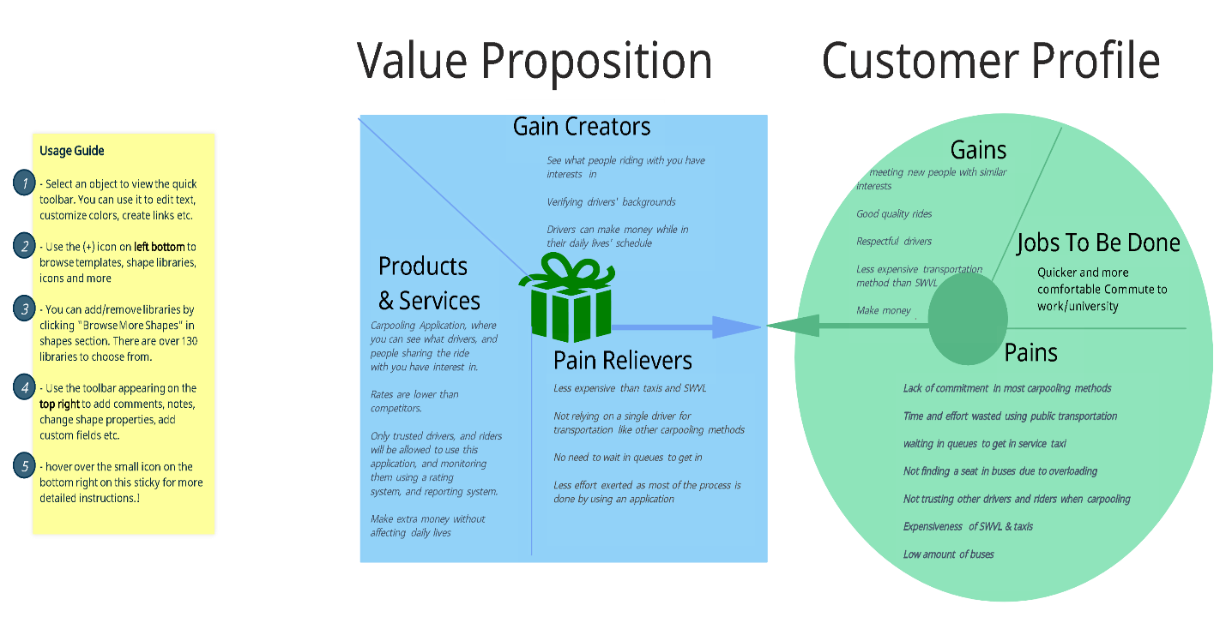

# III. The Solution

### Describe solution

The solution is an application that delivers passengers to the places they want, and the drivers are employees or students, and sometimes they are passengers, so that the customer can switch his account at the time he wants, whether a passenger or a driver as needed. It also offers the advantage of knowing the driver and passenger's personalities, so that a social relationship is established between them.

### Explain how the solution addresses the challenge

The challenge was to find a better alternative to public transportation at an affordable price so that students and young professionals can reduce the time and effort wasted while moving around. There were many ideas to solve this problem, but the idea of applying Tariq was unique in that it makes the driver earn money and go to the place they want without change. As for the passenger, he could go to the place he wanted at a reasonable price and without wasting time and effort while travelling. He could also trust the driver more and build a social relationship between everyone so that the passenger and driver determine the interests that he loves, and the application connects the passenger with the appropriate driver according to their interests

### Features

Features are elements of your product or service that make it special.

* Ease of use
* Lower Price
* Ease of switching the account between the passenger and the driver without the need to create a new account or download another application
* There will be rider and driver preferences to improve the rating
* The customer obtains discounts due to frequent use of the application.
* Good UI & UX
* Provide detailed reports on the history of the request
* Access real-time information about their requests

### Benefits

Benefits are the positive impact your product provides to the customer

* Reduce congestion in the streets
* Save Time & Money
* Spend less time while commuting
* Reduces carbon emissions
* To enhance efficiency by shortening transportation times and improving transportation methods
* Trusting the carpooling process

### describe how your customers currently solve their pain

People are currently getting rid of their pain by using taxis, service taxis, or smart applications such as Uber & Careem, etc., or using their personal or family car to prevent wasting time, because this requires a lot of money, so some use public transportation such as buses and bear all the pain and problems to save money

## Value Proposition Statement

For - low to middle-income employees/students in Jordan.

Who – face issues in public transportation and the carpooling process.

Tareeq- is a carpooling application that relies on commuting employees/students to give rides to commuting employees/students while going to work/university.

That unlike – SWVL, and other carpooling apps, doesn’t rely on full/part-time drivers, and doesn’t rely on station-to-station rides

Provides – organization of carpooling rides between drivers and riders, on a geographic and demographic basis

## Prototype

### Describe prototyping plan

|  |  |  |  |
| --- | --- | --- | --- |
| **Prototype** | **Validation** | **Observation** | **Next steps** |
| Application Prototype Version 1 (**Tareeq**) | Idea Validation (from the passenger's and driver's side)  Navigation  User-friendliness  Requirement testing | From Building:   1. Doing both sections of the app (driver & rider) using the same interface, proved to be difficult to organize. 2. We learned more from building, than actually thinking about building. 3. We need to add a different service (VIP Service) for a different revenue stream, and to attract more customers.     From Testing:   1. Our UI & UX needed some more work. 2. Users found it difficult to navigate to and from certain points in the application. 3. It took more time to test the prototype than planned, which means either our prototype needs more time to test, or it was too complicated for the users which means making it simpler would fit within the time frame foretold. 4. Some users understood the concept of the app fairly quickly, while others didn't. 5. Some users showed interest regarding the concept of riding with people with similar interests, and expressed that they like this idea and would want us to work more on it | We're considering removing the list (top corner) and rely only on one type of navigation which is the bottom navigation bar, because while observing the users we found many of them mainly using the bottom navigation bar, and when they realized what they're looking for isn't in there, they used the list (top corner).    We will also be adding more options in the "preferences" page so that it will allow longer trips to be fathomable.      Rewards for referrals |
| Application prototype Version 2 (**Tareeq**) | Idea Validation (from the passenger's and driver's side)  Navigation  User-friendliness  Requirement testing | We noticed that users still took more time to navigate and get the hang of the application, because some of them had never carpooled before and didn't understand what it is from our existing explanation in the about us page | We will be adding a detailed page containing a tutorial on how to use the app, so that people who have never carpooled can understand more about it. |
| Application prototype Version 3 (**Tareeq**) | Idea Validation (from the passenger's and driver's side)  Navigation  User-friendliness  Requirement testing | No negative feedback. The testing was finished within the time allocated for it | No next steps |

### Describe and present results of your prototyping work

#### Prototyping V1: -

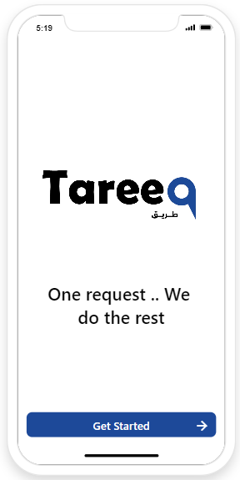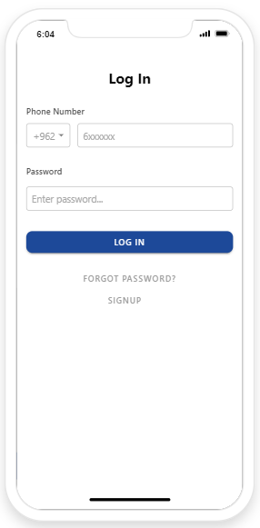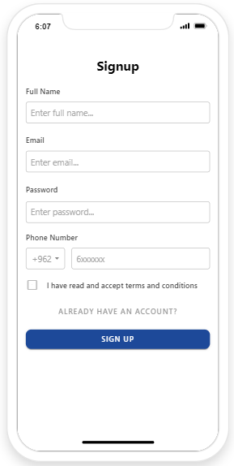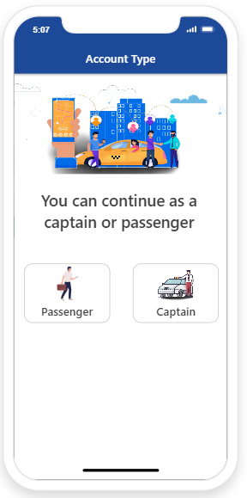

The first screen, which is the main page of the application, which contains the logo and name of the application, and contains the start button to move to the second screen, which is the login page if you have an account in the application, and you can click on the word Forget the password to request a new password, or press Sign up In the event that you are a new user, which will take you to the third screen, through which you can create a new account in the application, and after completing the login, you will move to the fourth screen, and here you will specify the type of account, and this means determining what you want to be a passenger or driver

To view the prototype, click on the link[8]

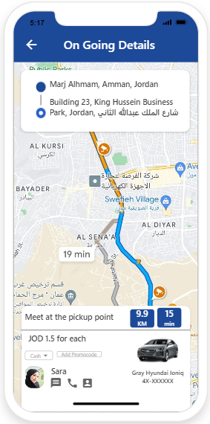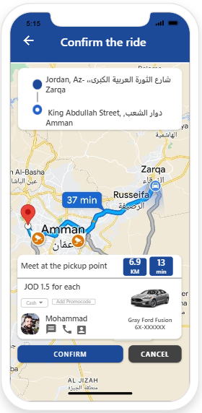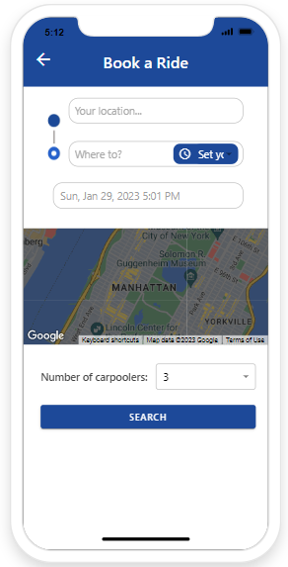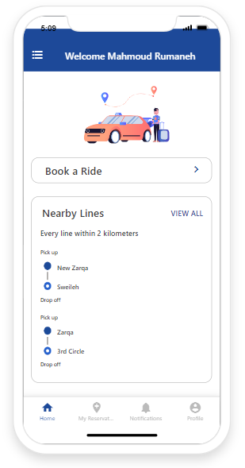**Prototyping the passenger v1 in case it starts the trip**

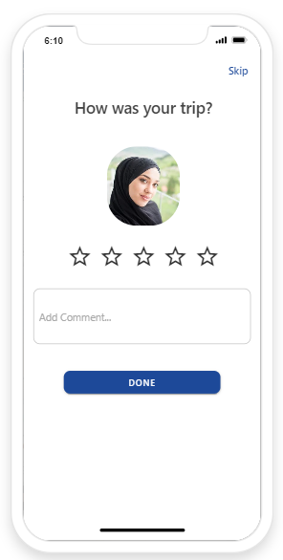

The first screen in the passenger account, which is the home page, through which he can start the trip, see the details of the current trip and previous trips, as well as he can go to notifications, go to the profile, modify the data, and also, he can define his interests, and also select payment methods, contact support, and switch the account type to driver and log out

In the event that the trip starts from the passenger’s home page and clicks on the Book a Ride button, then you will move to the second screen, through which you can start the trip from, where it will end, at what time you want, and how many people are on this trip, and then click on Search and through it The application will search for a driver going in the same way that you want, also based on interests and preferences, and after finding

the driver, you will be transferred to the third screen, which contains information about the trip from where to start and where to get off, as well as additional information about the driver, his name, phone number, car number, type, and payment method Cash or visa, how much distance and time for this trip, and in the event of confirmation, press Continue or press Cancel to stop the trip. In the event of follow-up, you will move to the fourth screen, which will show where you are and how much distance and time remain to reach the access point, then after the arrival point reaches the driver will press on the end of the trip, then you will move to the fifth screen, which will show the evaluation and feedback page for the driver, and then the trip will end

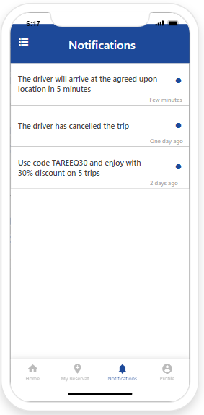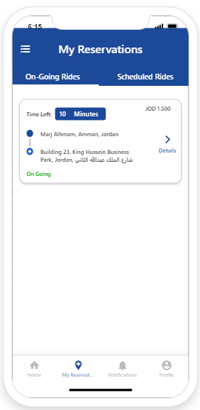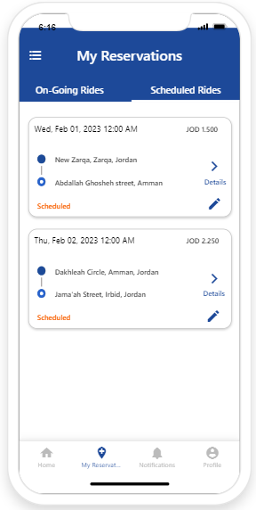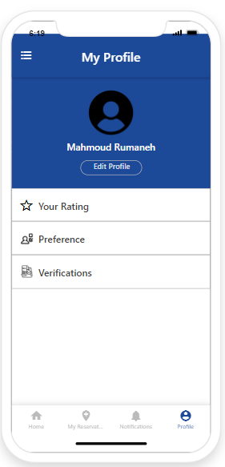**Other screen passenger prototyping v1:**

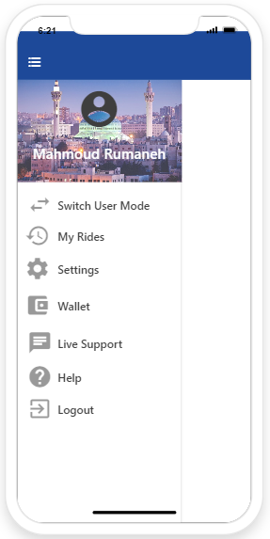

The first screen here is a page to show the current flights, and you can also click on the details to find more information about the flight

The second screen, which is a page of the history of previous trips, and you can click on the details to see more information, such as the price and the driver that you rode with, and in case you want to take the trip again, you can click on the pen to adjust the start time of the trip

The third screen, which is the notifications, through which you receive any important notifications, for example, a notification that the driver will reach you within a whisper of minutes, or cancel the trip, or obtain discounts, or if you contact support and answer inquiries

The fourth screen, which is a personal profile, through which you can modify information such as name, number, and put a personal picture, and you can also enter your personal ratings to see the drivers’ rating for you, and you can also modify some preferences such as smoking, talking to the driver, music, internet, air conditioning, charger, and it also contains verification if you want to check your email, number, personal ID

The fifth screen, which is the navigation bar, which is on the home page at the top. When you click on it, this menu appears, through which you can switch the account, view previous trips, go to settings, select the payment methods you want, direct support and assistance, or FAQ, and log out

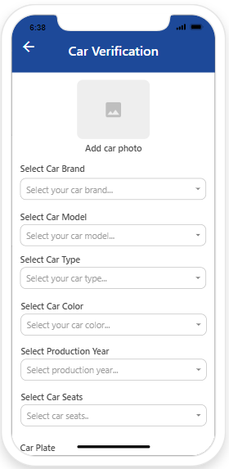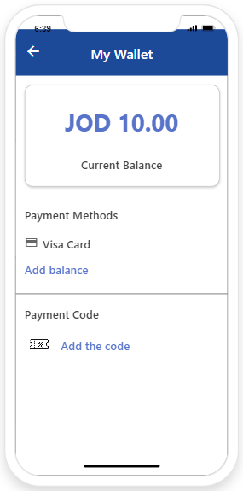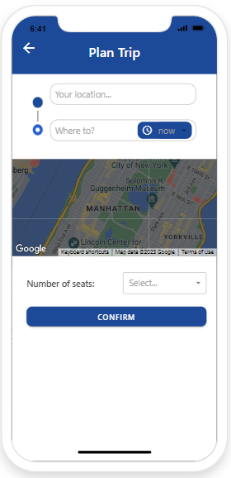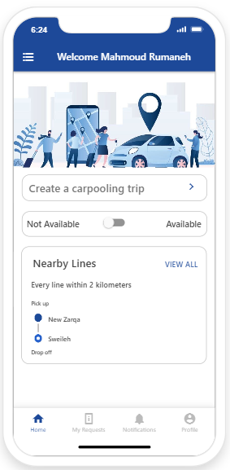**Prototyping the driver v1 in case it starts the trip:**

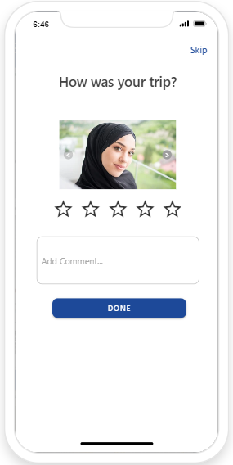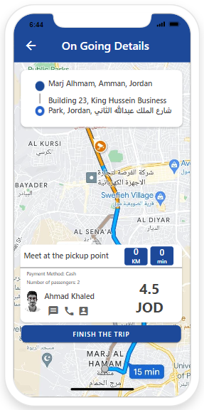

The first screen on the driver page, which is the home page, through which you can navigate to all the screens on the passenger page, such as the navigation bar, start receiving trips, go to the trip history, current trips, check the car he is working on, notifications, and the profile

In the case of receiving trips, first from the home page, click on Available, then click on Create a carpooling a trip, then you will move to the second screen, which is a verification work for the car you want to start the trip with if you do it for the first time, and then you will move to the third screen, which Through it, you will put money in the application wallet to ensure protection and not evade payment, and then move to the fourth screen and specify the start and finish place of departure, determine the departure time and the number of passengers available to you, and then press follow-up and search for passengers, and then you will move to the fifth screen, which Information will appear about the passenger, the place of departure and completion, the amount to be paid, the distance and time on this trip, and additional information for the passenger, such as the number, profile, and personal photo, and then pressing accept. Other trips if you want to follow up

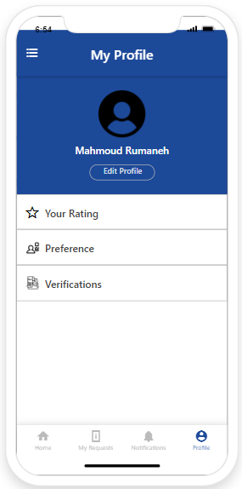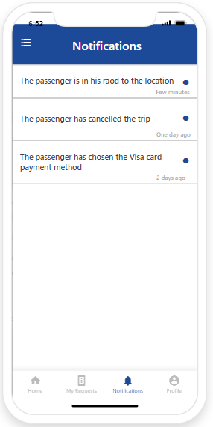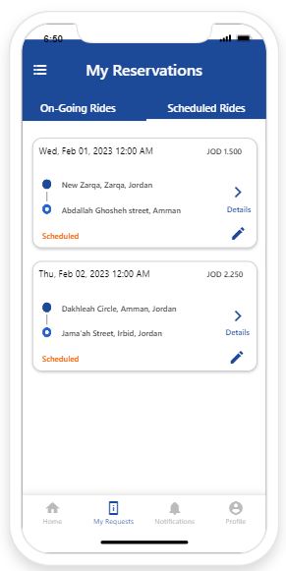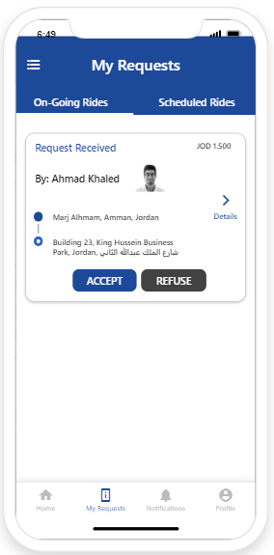**Other screen driver prototyping v1:**

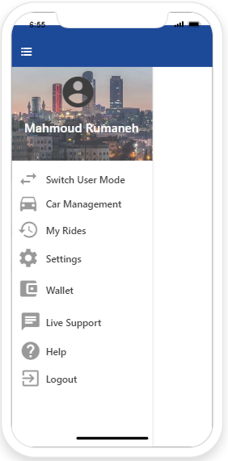

The first screen, which is the current trips that the driver takes, and he can accept or reject, and he can view the details of this trip

The second screen, which is a log of the trips that he made, can know the details of the trip

The third screen, which is the notification screen that the driver receives, and it consists of messages such as that there is a passenger 2 km away, or that the passenger canceled the request

The fourth screen, which is a personal profile, where the driver can modify his personal data, view the ratings he receives from the passengers, and also set his personal preferences, as if he smokes, likes to listen to music, etc., and also checks the email, number, personal ID, and the car.

The fifth screen, which is the navigation bar, which is located on the driver's home page, and there is a switch for the account type, his car information, his trip history, settings, payment methods, direct support, help or FAQ, and logout.

#### Prototyping v2:

In prototyping v2 we have modified some pages and added new pages, which we will review in this section are the new modifications only

Modifications on passenger: -

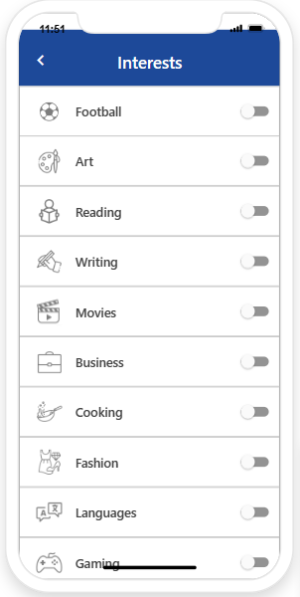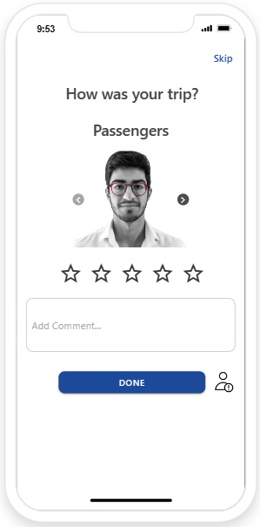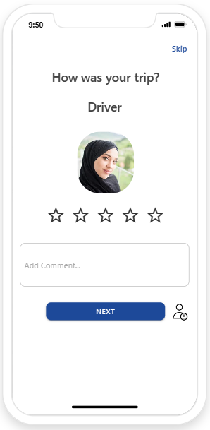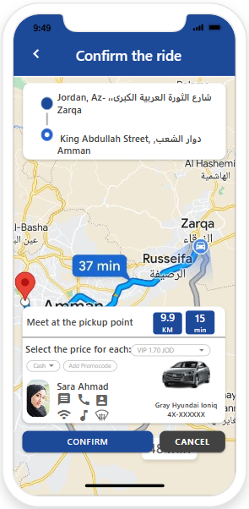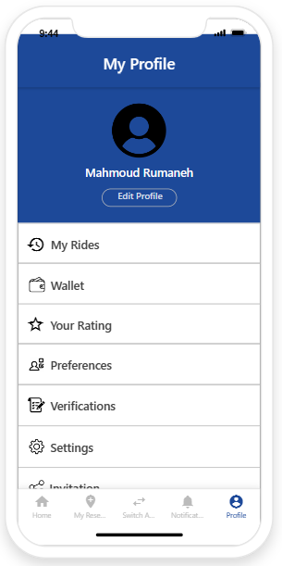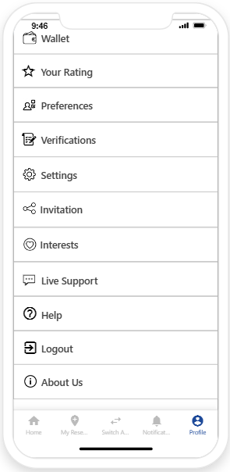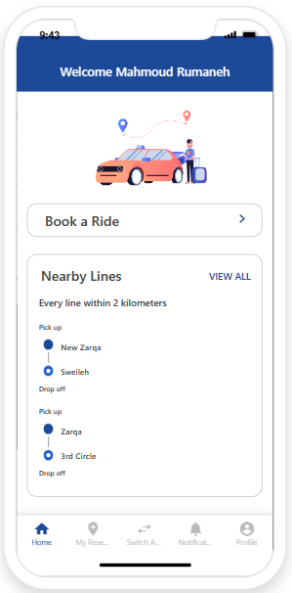

The first screen is the main page of the passenger. We removed the navigation bar and put the properties in the profile screen. As for the feature of switching the account type, we put it in the bottom menu in the middle

The second, third and seventh screen is the passenger’s profile, which we have added some features, including trip history, payment method, ratings that the passenger gets from the driver and other passengers, preferences, checking the number, identity, personal email, and settings. We also added a new feature in the application, which is interests, which are the interests of the passenger, such as Football, drawing, reading, movies, cooking, etc. in order to suit the interests of the driver to improve the evaluation, and also among the features are direct support, help or FAQ, sign out and about the application, which is a new feature that explains what the application is and there is a video explaining how you can use the application

The fourth screen, which is a screen that appears after specifying the place of departure and end and the start of the trip, which shows some information about the driver and what are the preferences such as air conditioning, music and the Internet. As the maximum distance, it shows the car's information, number and type

The fifth screen, which is the evaluation after the end of the trip, the passenger evaluates the driver and provides feedback, and we added a new feature, which is that he can add the driver as a friend to improve relations between customers and improve reviews

The sixth screen is the evaluations as well, but the evaluation of passengers who board together so that all passengers evaluate each other to improve the user experience and build trust between customers and the company

To view the prototype, click on the link[9]

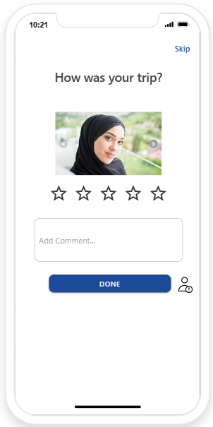**Modifications on driver: -**

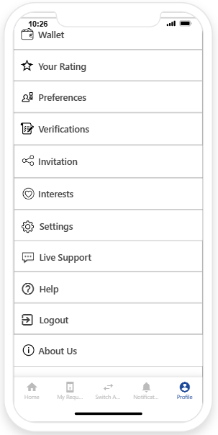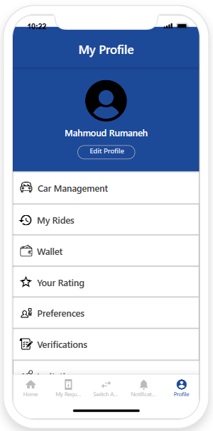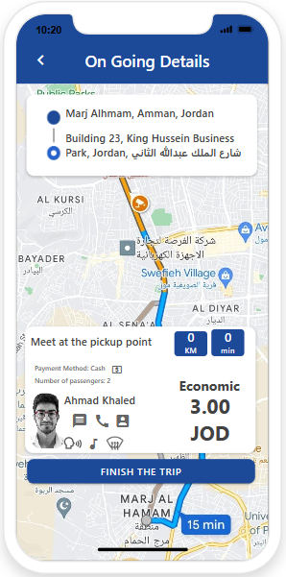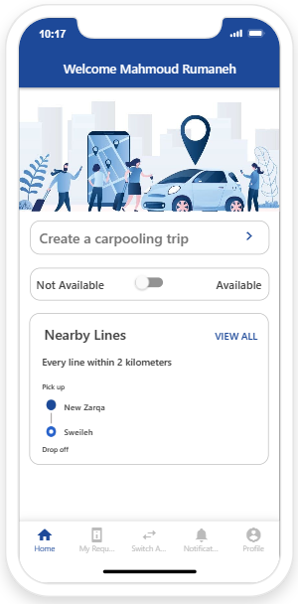

The first screen is on the main page of the passenger. Here we removed the navigation bar that was at the top and put the properties in the profile and added the account type switch in the bottom menu

The second screen is a page among the pages through which the passenger is accepted and some details and information are shown for the passenger, including the main preferences that he likes, the price, and adding whether he is a normal or VIP

The third screen, which is the reviews, to which we have added a friend request, helps the driver and the passenger to have a social relationship to improve the rating and make the customers happier.

The fourth and fifth screen, which is the profile, which contains car management, its information, trip history, payment, ratings, preferences, checking the main information, and the invitation that we added to increase customers, through which the driver gets to take a trip for free, as well as interests such as love for movies, football, books, etc., as well as settings and support Direct assistance or FAQ, as well as sign out and about the application, which is a new feature that allows the driver to know how to use the application

#### Prototyping v3

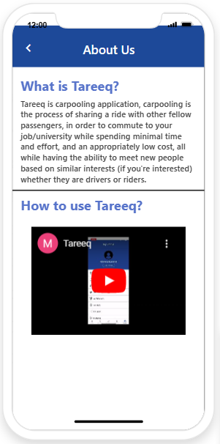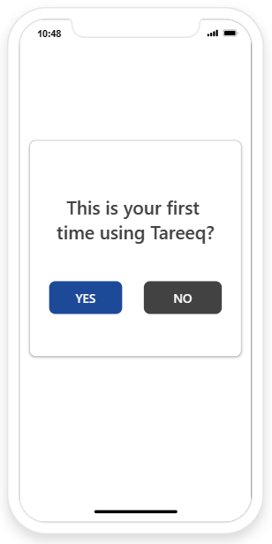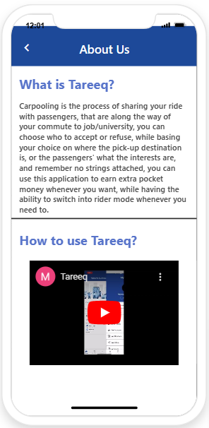We made a very simple modification to the second prototyping so that we added a simple thing, which is when he finishes logging in and specifying what he wants to be a driver or a passenger, then after that a screen will appear for him if he is using this application for the first time or not, and if he presses No, he will go to The main page is either for the driver or the passenger, depending on what he chose the type of account, but if he clicked on Yes, information about the application and how it can be used will appear to him

Insights From Prototype Evaluation:

After completing the first prototyping, we showed it to people, and they gave us notes, and we explained the additions that we will make on the V2 and told us that it will become special, and they benefited us a lot. They told us that the navigation bar at the top in the V1 seemed annoying, and they also told us that the application initially needs explanations to understand it Then we corrected the errors and took the notes into consideration and applied these things in the second prototype and we filmed them with a video and put pictures of them at the bottom, which made positive comments in terms of design, ease of use and speed in understanding the application and told us that the interests and preferences in the application are not present in any of the applications others express their admiration for the new ideas within our application

# IV. Business Model

### Business Model Canvas

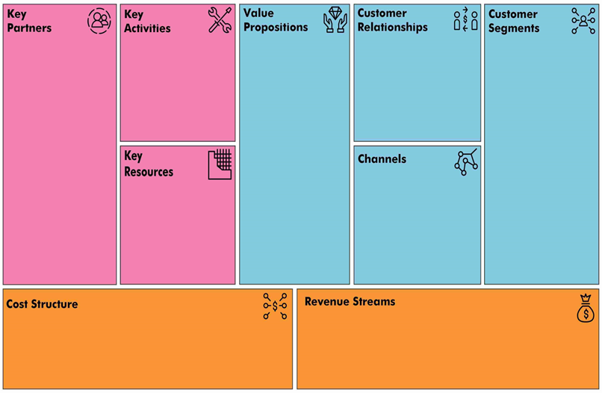

Rating & comment for rider and driver

Rider & driver preferences

Live support

Save Time & low price

Opportunity to make money

Flexible & ease of use

Provide detailed reports on the history of the request

Trusting the carpooling process

Earning a small percentage of each ride That comes to about 15%. (This cost covers the expense of using our software for the trip)

This percentage will be can either be taken as cash or visa

Variable cost: -

* Social media advertisements
* Fees paid to the driver
* Marketing

Fixed cost: -

* Taxes
* Office rent
* Salaries
* Equipment
* AWS services

Website

Instagram & Facebook

Application

Advertisements

Word of mouth

Marketing & social media

Employees (Designer,

 Developers, Customer service)

Office

Equipment

AWS services

Job Commuters

University commuters

Both of those segments can be drivers and riders

People who already carpool using other methods such as Facebook groups

Universities

Gas stations

Organizing customers' data

Maintenance app

R&D

Advertising on social media

Live support

### Explain blocks in Business Model Canvas

**Key partners:** Tareeq's most important partners are public and private universities, as well as petrol stations, because they can provide services to application users such as discounts, and they will also help us get more customers by promoting our application

**Key activity:** Tareeq's activities include making our customers reach us by following our pages through social media such as Facebook, Instagram, etc., and also through our website, as well as customer service and inquiries to find out problems, improve them, organize data, and also do maintenance for the application on a regular basis to improve the service provided to the customer, such as improving the user interface and user experience

**Key resources:** Staff, equipment, and offices are Tareeq’s main resources, as well as marketing and social media professionals, as well as AWS Services

**Value proposition:** The most important value of our solution is that the application saves time and money, helps to earn money, is flexible and easy to use, provides detailed reports on the history of trip requests, and helps to have better confidence during car sharing

**Customer relationships:** We can interact with customers by obtaining comments and evaluations after the end of the trips, and the trips are organized according to the interests and preferences of both the passenger and the driver in order to obtain positive ratings in a large way. You can also communicate with customer service and explain the problems that you encountered while using the application

**Channels:** We will reach customers through social media platforms, website, advertisements and also word of mouth

### aspects of the Business Model

Our business model is unique in the way it provides service to our customers by reimagining a new method of transportation, which is characterized by providing better service to customers and improving the way of transportation and makes the customer more comfortable and happy because it got rid of the burden of thinking about transportation, which makes us gain value for our application and a good reputation It will also be beneficial because it reduces traffic congestion and environmental pollution

## Revenue Model

### explain revenue model

* Our first revenue comes from commissions on customer trip (15%)
* Our second revenue comes from advertising on social media and our application

Revenue model parts:

1. driver: gets money from passenger, we take 15% commission on all payments he gets, as compensation for using our software
2. passenger: pays for the trip, money goes to the driver
3. other companies: we advertise other companies in exchange for payments, advertising can occur on both social media, and application, with the application advertising costing more

|  |  |  |
| --- | --- | --- |
| **Customer Segments** | **Product/service** | **Revenue Stream(s)** |
| 1. Rider segments | Basic Rides (Meet the driver at a specified destination on the way) | *One time transaction.* |
| 1. Rider segments | VIP Rides (The driver comes to pick you up for extra money) (the driver can refuse) | *One time transaction.* |
| 1. Other companies | Advertising those companies | *One time transaction.* / Recurring |

# V. Market Analysis

### Where product lunch

We will start our project in Jordan, Amman, and we will start renting a place near Mecca Street, in which the headquarters of our company will be, and we will conclude many deals and advertisements in order to expand the market, and it will be the actual start of the project

In the future, the application will include other governorates such as Zarqa and Irbid, and it can also be outside Jordan in the Emirates and Saudi Arabia. Moreover, there will be additional services such as adding services such as the driver being a tour guide for tourists from outside the country in order to get to know the areas, as well as food and equipment delivery service. There may also be new sponsors for the project in order to expand the market further.

## Market Segment & Size

### Describe market size

|  |  |
| --- | --- |
| **TAM**    Total Addressable Market | **What is the total market demand for your product or service?**  Ex. Carpooling app targets all carpoolers in the world  *How did you determine your TAM? List important assumptions made.*   * *Revenue in the Car-sharing segment is projected to reach US$11.88bn in 2022.* [10] * *In the Car-sharing segment, the number of users is expected to amount to 62.1m users by 2027.* [11]   How did you determine your TAM? List important assumptions made.   * We used the statistics on a website called Statista. * Number of projected car-sharing users |
| **SAM**    Total Attainable Market | **What is the segment of the TAM targeted by your products and services which is within your reach?**  Ex. Our carpooling app targets all carpoolers in Jordan  *How did you determine your SAM? List important assumptions made.*   * Revenue in the Ride-hailing & Taxi segment in Jordan is projected to reach 214M $ in 2022. [12] * The average revenue per user (ARPU) is expected to amount to US$116.30. [13]   How did you determine your TAM? List important assumptions made.   * We used the statistics on a website called Statista. |
| **SOM**    Total Obtainable Market | **What is the portion of SAM that you can reasonably capture within the first 3 years?**  *Our carpooling app targets 30% of carpoolers in Jordan (65M $) by 7-9 years*  *How did you determine your SAM? List important assumptions made.*   * *Logical percentage*   How did you determine your TAM? List important assumptions made.   * We used the statistics on a website called Statista. * Number of people in carpooling groups. * The amount of people that we can realistically reach through ads |

### Describe market growth

Tareeq will have a modern and different growth strategy. This strategy is represented in the expansion of the Jordanian market, and this is done by signing agreements between famous companies, and also placing banners in the streets introducing ourselves and what we can offer to the community that includes our logo. We can put an explanatory video, and we will put the main sponsors of the project or the like, and also, we will carry out marketing campaigns on social media, this helps to monopolize the market in a large way, and then we will expand to Arab countries to increase profits, and we can provide other distinguished services that help to expand further in the market.

### market segment and customr persona

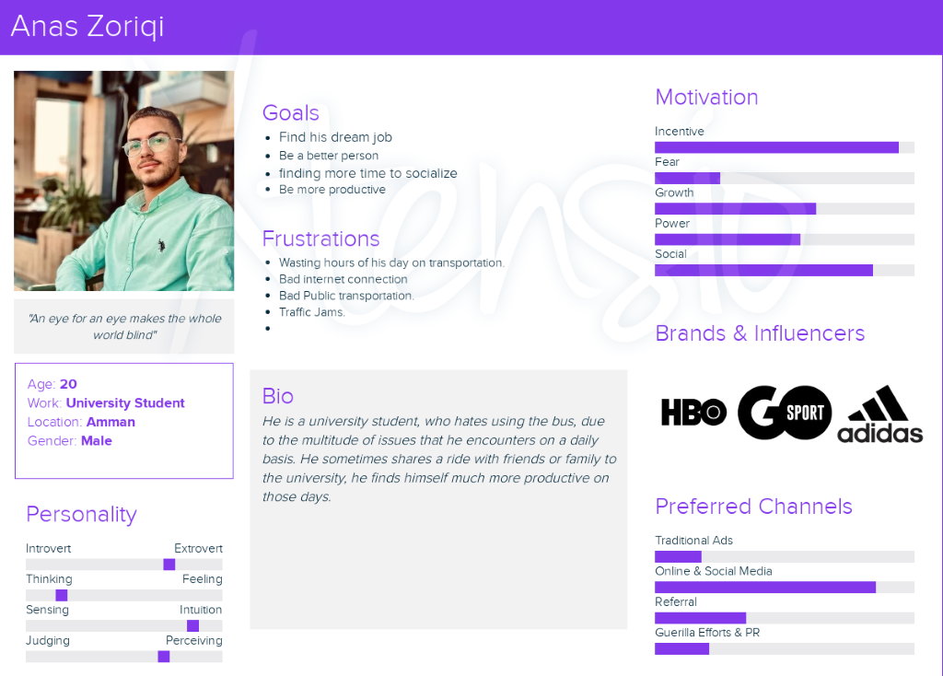

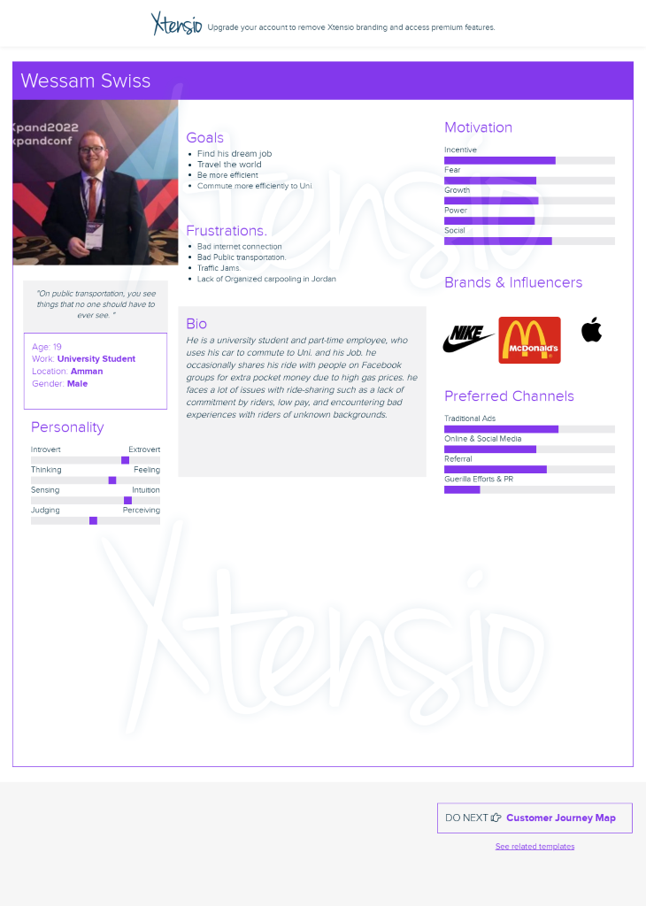

### Expected percentage of som market in the first 3 years

Given that the volume of the transportation market in Jordan is large and is considered one of the important markets, and since the carpooling market is considered one of the new markets in Jordan, and there are not many well-known companies in this field, so the market is considered unclear and the percentage taken from the market will not be understood. Nevertheless, we have found many statistics that help in the market knowledge, revenues in the taxi sector are expected to reach $214 million in 2022, and the average revenue per user is also expected to be $116. As for our application, it will target 30% of car users in Jordan in 7-9 years, at a value of $65 million, and based on assumptions. The number of trips in the first year is 25,320 trips or 0.55% of the market. As for the number of trips in the second year, it is 120,600 trips or 2.7% of the market. The number of trips in the third year is 258,000, or 5.7%. For the coming years, the percentage will increase because There are additional services, which makes the percentage unknown with the new services that we will provide in the future

## Primary Market Research

### Describe Primary Market Research

The basic research strategy was through interviews and surveys, and the main objective of the research was to find out the problems that people suffer from, the concerns about transportation, the methods used in transportation, and the negative and positive effects of using these methods. After completing the research and collecting about 156 responses, the following was found:[14]

* 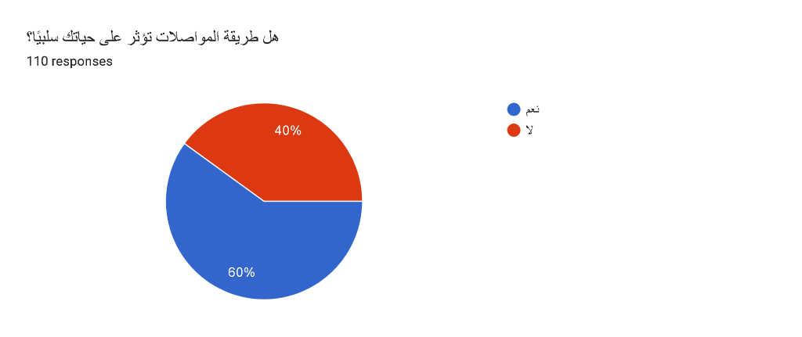We found that 60% of people who use a mode of transportation affect their lives negatively
* We found that both sexes use public transportation on a daily basis

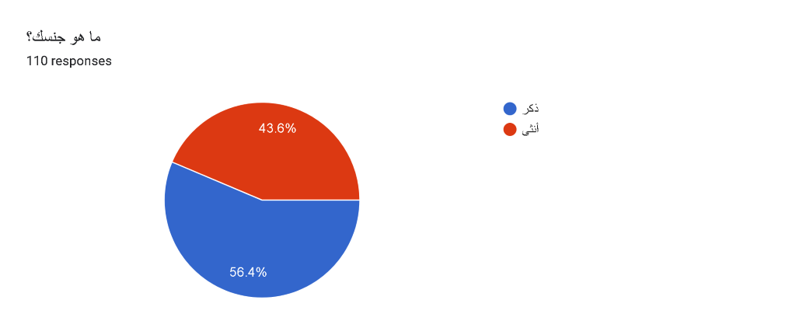

* 44.7% of drivers said that people would not buy new cars if there were fairly excellent means of transportation

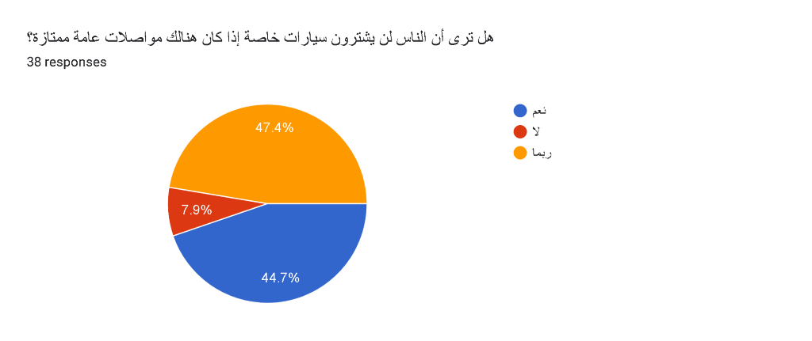

* 66.4% of people said that public transport is not always accessible, which is why it is one of the main factors why public transport deters new users

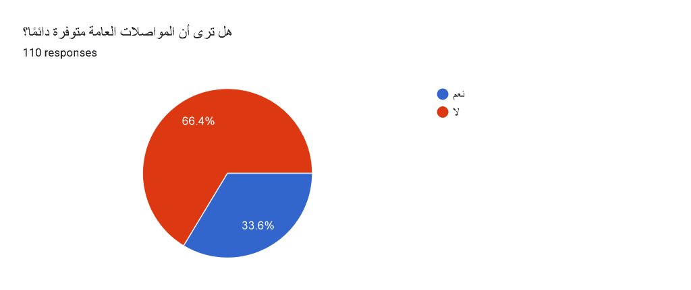

* 41% of commuters said it takes more than 1 hour of their daily lives, 27% per cent said they waste around an hour
* About 66% of the people, we asked reported negative experiences in several areas of carpooling
* Most of the car users we interviewed said that the driver can and is more likely to leave them without warning if he finds someone overpaying, and this has happened to them before

Finally, we found that Jordan prefers to use public transportation because it saves money despite wasting time and effort instead of using smart applications and taxis, because it costs 3 to 4 times the price it pays for public transportation. Effort and a nice price will make everyone be happy

## Secondary Market Research

### Describe Secondary Market Research

In the secondary research that we conducted, the strategy was to study the problems that people suffer while moving around three categories around the world, the Middle East and Jordan, and this helped to better understand the market and enter.

At the beginning of the search, we found the following:

* Global ratios are approximately one bus per 1,000 residents, while in Jordan it is one bus per 3,000 people.[15]
* Currently, there are an estimated 20 million vehicles in global car-sharing projects. Just under 45 million vehicles are expected to be in global car-sharing programs by 2025[16]
* It is expected that revenues worldwide in 2022 will reach 11.88 billion dollars in the car-sharing sector, and the number of users is expected to reach 62.1 million users in 2027[17]
* The number of taxis in Jordan is 17,000, of which 11,400 are in Amman[18]
* The number of rapid bus stations is five stations, about 150 buses with a capacity of 120-150 passengers per bus, and it is expected that 200 thousand passengers will use it daily[19]

This research shows the numbers of the market that we will enter and the potential competition, in addition to that it shows that the emerging Tariq company is urgent to study the market more to enter the competition due to the presence of giant competing companies, but we will be specialized in certain categories that we provide them with the service.

## Competitive Landscape

### direct and indirect competitors

Direct Competitors: -

* **SWVL:**provides delivery services, especially carpooling, and they are the most well-known in the carpooling market. Although their services are currently suspended, many customers complain about the high prices and lack of availability of the service. It is also not easy to use on the driver and passenger side. Also, lack of communication from SWVL is a big problem as many people don't know whether they are operating or not.

* **Facebook & WhatsApp Groups:**unregulated carpooling occurs on many groups dedicated for carpooling, each for group is dedicated to people living in a certain city. Number of people in these groups are proportionally extremely low when compared with the population of the city. Prices are not consistent and vary from driver to driver, usually there is no trust when dealing with new drivers or riders, as they have unknown backgrounds.

Indirect Competitors: -

* **Uber** provides delivery services, and it is the largest in the market, and although the prices of their services are above average, they do not target all groups, as their services are relatively expensive for long-distance transportation, and on the driver’s side, they require some complications.

### Different between TAreeq and direct Competitors: -

|  |  |  |  |
| --- | --- | --- | --- |
|  | **Your startup** | **Competitor 1** | **Competitor 2** |
| **Company overview** | Tareeq: delivery service and an opportunity earn money | Facebook & WhatsApp groups | SWVL: delivery services |
| **Type of competition** |  | Direct competitors | Direct Competitors |
| **Value proposition** | Delivery service at excellent prices for a group of people, and an opportunity to make money, with regulated pricing, rating and reporting system, and the ability to ride with people with similar interests | Delivery service at varying prices for a group of people, and an opportunity to make money | Delivery service at good prices for a group of people |
| **Target market** | People from the low class to the middle class, from 18 to 35 years old, male and female. | People from the low class to the middle class, from 18 to 60 years old, male and female. | People from the low class to the middle class, from 25 to 34 years old, male and female. |
| **Products & services** | Carpooling application, with lower rates than competitors, with only trusted drivers and rider allowed on the app, by utilizing rating and reporting system, make extra money without affecting daily lives | Carpooling group, unregulated carpooling. Certain arrangements happen between drivers and riders based on posts they've made regarding the exact whereabout of the starting point, destination, and the way between. | Group delivery services and providing semi-formal work |
| **Costing & prices** | For each person  start 0.5  (0.05 JOD per kilometer)  0.01 per minute | Varies from driver to driver | Base Fare + ((Cost per minute x time of the ride) + (cost per mile x ride distance) x surge boost multiplier) + booking fee = Passengers Ride Fare |
| **Marketing strategy** | We will reach our customers through:  *Social media marketing = daily*  *Mobile marketing*  *Search engine optimization*  *Networking*  *Word-of-mouth*  *Referrals* | Social media marketing  Referrals  Word of mouth |  |

**Unique Competitive Advantage for Tareeq:**

Our application services are distinguished in several respects, the simplest of which is the appropriate price for all categories, and the most important of which is that the application is used by two types of users, the driver and the passenger, and each party can be the other so that the driver does not remain a driver and he is not forced to work and can be a passenger. The service of knowing the interests of the driver and the passenger for each other, so that we provide a comfortable and pleasant trip for both parties

# VI. Go-To-Market Strategy

## Marketing 4 Ps

### Define Tareeq attributes and benefits

A carpooling application that any individual over 18 years of age can partake in.

Key Features:

* Ease of switching the account between the passenger and the driver without the need to create a new account or download another application
* There will be rider and driver preferences to improve the rating

Key benefits:

* Reduce congestion in the streets
* Spend less time while commuting
* Trusting the carpooling process

### Define Pricing strategy

Free, only requires internet to download, the rate of the service is 15% per ride

**Cost +**

* we calculated our costs and added a mark-up,
* our pricing is 0.5 to start the trip, 0.05 for each KM, and 0.01 per min, (pricing for the economical ride)
* our pricing is 0.5 to start the trip, 0.05 for each KM, and 0.01 per min,  
  and adding 0.20 for each added KM and 0.04 for each added minute (pricing for the VIP ride)

### Define place (distribution channels)

*Online application, they can find it on app store, and google play* for free

* Website
* Instagram & Facebook
* Application
* Advertisements
* Word of mouth

### Define Promotion Channels (And cost-related)

Advertisings:

* Online marketing
* Radio
* Cable television
* Out-of-home

We will reach our customers through:

* Social media marketing = daily
* Mobile Marketing
* Search engine optimization
* Networking
* Word-of-mouth
* Referrals

## Branding

### logo

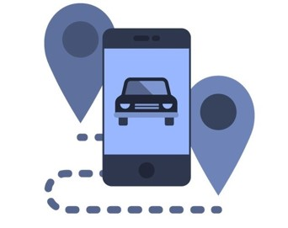



The color navy blue representing trust & stability.

### What is the meaning of your logo?

The multiple GPS drop points represent the many passengers that can ride the single car in the logo, with the road connecting all of them together. The name Tareeq meaning “Road” or as we use it in slang to mean I’m along the way of your trip, representing the fact that drivers wouldn’t have to drive far to get their passengers. And that passengers wouldn’t have to wait for too long to find a trip.

### What is your main brand’s message? Promise?

* The ease of use, as our slogan indicates. “One request we do the rest.”
* Tareeq the name representing. Assurance that you won’t have to drive too far or wait too long.
* Less time and effort wasted.
* Extra pocket money.
* No strings attached.
* Flexibility.

## Go-To-Market Plan

### Briefly describe your (GTM) marketing Goals

* Reaching 20000 trip in the first year.
* Signing a contract with governmental and private universities
* Sign contracts with gas stations.
* Sign contracts with sponsors.

### Explains the aspects of GTM strategy

* Signing a contract with governmental and private universities. // to gain publicity in exchange for organizing trips between their students. Targeting hitting 50000 trips per university per semester.
* Sign contracts with gas station. // to enable offline payments through card exchange and not rely solely on visa payments.
* sign contracts with sponsors. // to get more publicity, in addition to advertising ourselves on other companies’ social media/application.

# VII. Financials

## Cost Structure

### Initial Start-Up Cost

### Fixed Cost (Operating expenses) Per Month

### Variable Cost Per One Unit

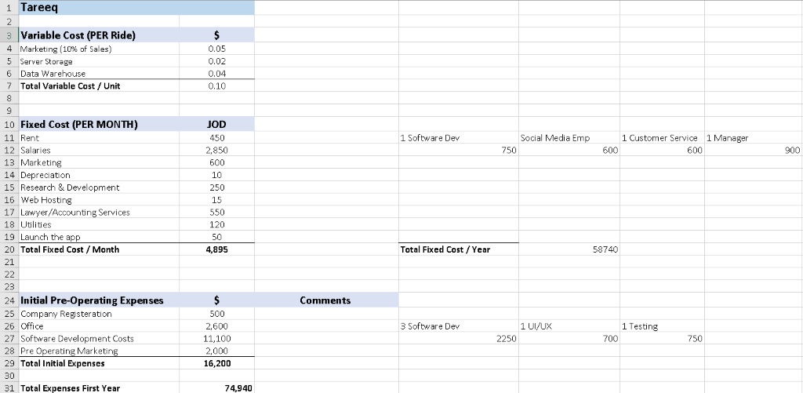

### relevant assumptions

Regarding the development of the application and website, we will require 3 software developers with each costing 750 JDs for each month of work (average salary of a software developer in Jordan is 8740, which means around 730 monthly), 1 UI/UX designer (700 JDs), and 1 tester (750 JDs). The application will take 3 months to develop according to our research.

As for our variable costs, due to us using AWS service to host our data (0.04 per ride), and tableau software for data warehousing (0.02 per ride) and having a portion of our sales being used for marketing will take a toll on each ride’s revenue.

After the development of the app has finished, we will require one of each of the following professions, 1 Software Dev, 1 social media Emp, 1 Customer Service, 1 Manager, 1 accountant, and a fixed amount of cash for marketing, all these costs re-occur each month

In the future we will consider not having employees, and rely on outsourcing, to get rid of fixed costs and rely mainly on variable costs as it will make it easier for our application to generate more profit.

## Pricing

### pricing model and strategy

Pricing Strategies:

* Cost-plus pricing—simply calculating your costs and adding a mark-up

15% commissions on all trips

### Include pricing for all services and/or products you intend to sell upon launch.

## Breakeven Analysis

### break-even point

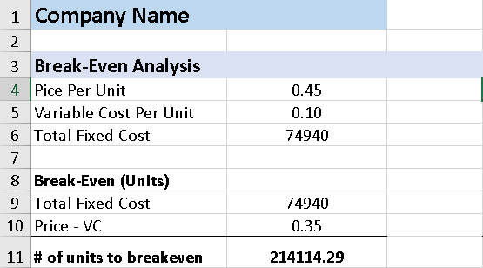

Present your break-even point in terms of revenues

2141114.29*0.45 = 96,350 JD

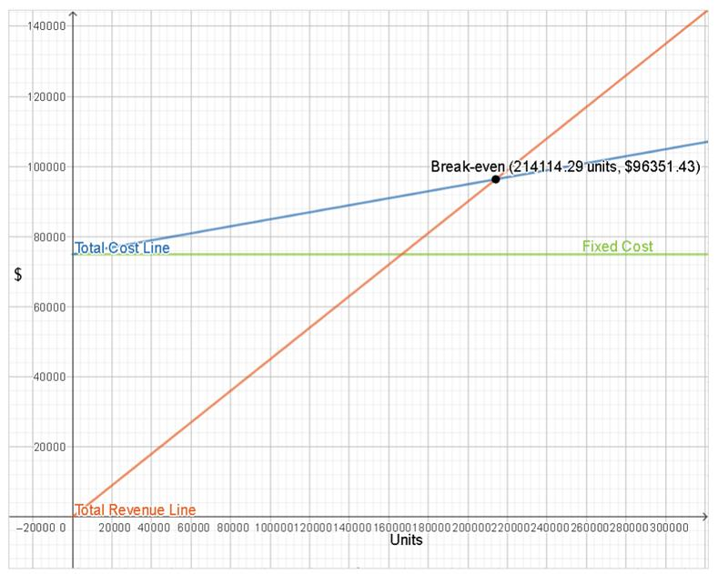

## Income Statement

### Volume projection

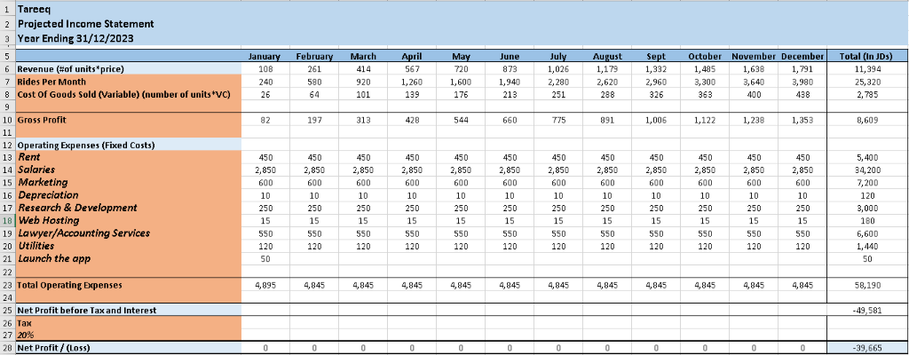**First year:** -

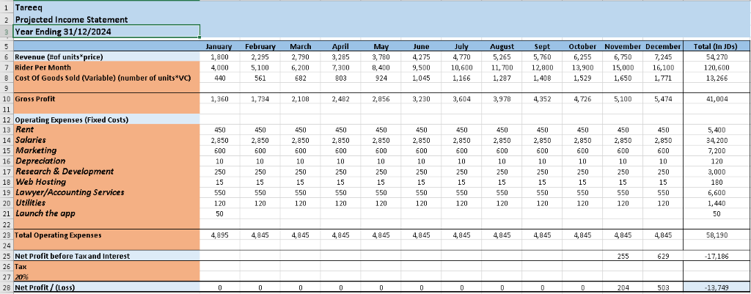**Second year:** -

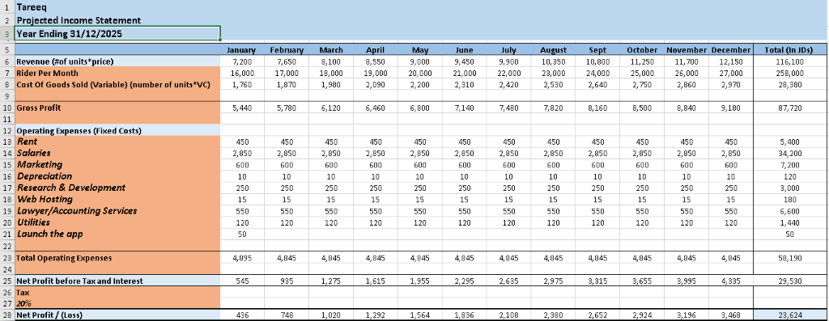**Third year**: -

# VIII. Final Statement

### As team your experience in the bootcamp and working together

We've enjoyed working as a unit and getting things done. Each group member contributed their own skills and opinions, which contributed to the development of an effective team.

The efficiency of our team's communication was one of our best strengths. We made sure to arrange frequent meetings and check-ins. We also communicated and shared information using a range of methods, including email, WhatsApp, face-to-face meetings, and Teams Conferencing.

While we all knew each other 3 months prior to the bootcamp, we struggled at first to communicate our ideas effectively, especially during online meetings, because at it turns out for us, we relied heavily on body language and physical comedy to convey our thoughts.

We also emphasized the importance of dividing up tasks and responsibilities according to the skills and passions of each team member. This made it easier to maintain everyone's interest and drive to support the team's success. Additionally, we were able to develop a relationship of trust and rely on one another to complete tasks.

For example, all things design were left for Mahmoud as he enjoys it a lot, while saif handled the financials, because he had a knack for it growing up in a family full of bank workers, izzat handled all things related to pricing and verifying what’s doable and what’s not, while Hasan handled all things social, by leading us to the right people, handling interviews, and verbal communications. That way everyone did what they loved and excelled at, felt useful and contributing to a greater purpose.

Overall, it was a very positive experience working together, and if presented the opportunity we would love to work together again.

### Highlight insights, important learnings and mindset transformation

1. Empathy: to understand and share the feelings of others. I don’t think any of us at first could’ve managed to do that, as we always relied on surveys and quantitative methods to get data, however, while quantitative data is important to gauge out the size of the problem, we discovered that qualitative data has many benefits as well, which are feelings and experiences these are things that you can never get with quantitative research, so we learned that incorporating both into our research is the way to go.
2. Asking the right questions: at the start of this bootcamp, while researching we asked surface-level questions, however after learning more about research, we began to ask the right questions. For example, at first when asking about a problem, we would disregard what the user is now doing to solve his problem, and that’s a big mistake, that is one more question that we will start to ask more when researching.
3. Building to learn: all our life, we learned that in order to build something, you first have to learn it, going through this bootcamp taught us otherwise, because by building initial versions of our prototype we learned more than we could ever hope to by reading about it or looking it up.

### Leave us with an inspirational last statement

The only way to do great work is to love what you do.

# Appendices

## Appendix 1 – Development Work

### Team Canvas

### mindmaps

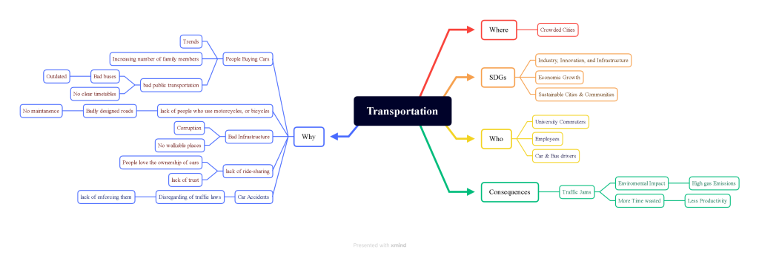

### Customer journey maps

**Driver journey: -**

[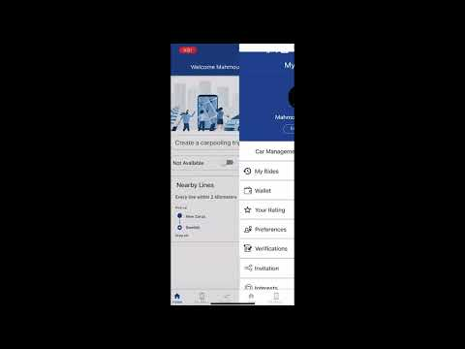](https://www.youtube.com/embed/eBKGTPeE_HU?feature=oembed)

**Rider journey: -**

[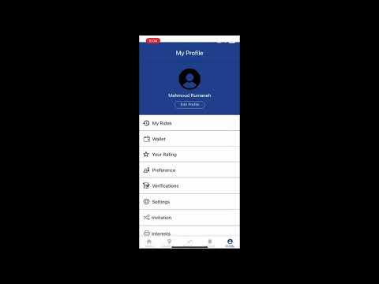](https://www.youtube.com/embed/XZZ0atPEUpI?feature=oembed)

### Idea Brainstorming

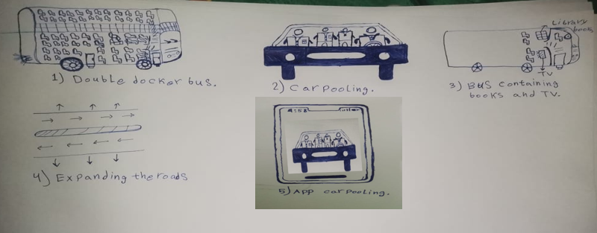

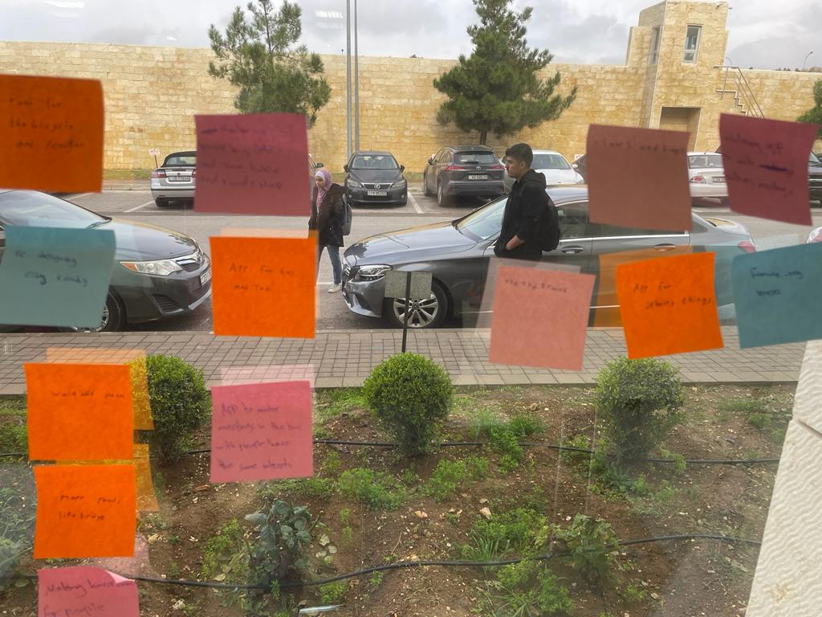

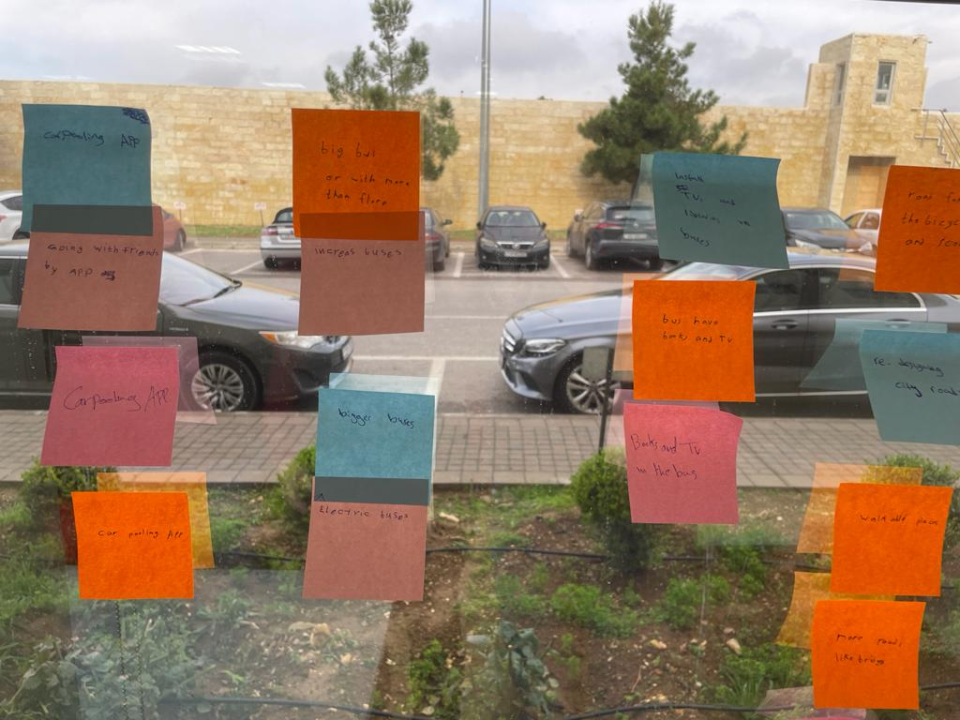

### People's opinions about the project

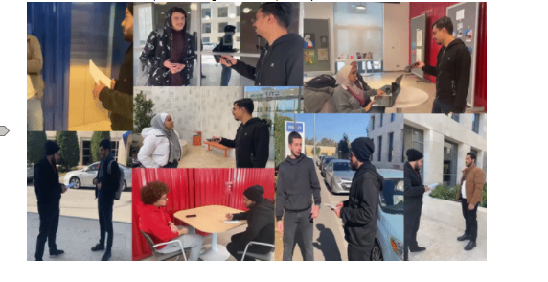

### pmr data

Are you a driver or a passenger?

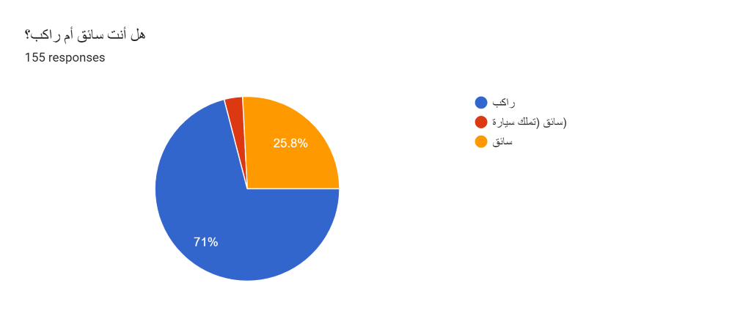

A) If a passenger

1) How old are you?

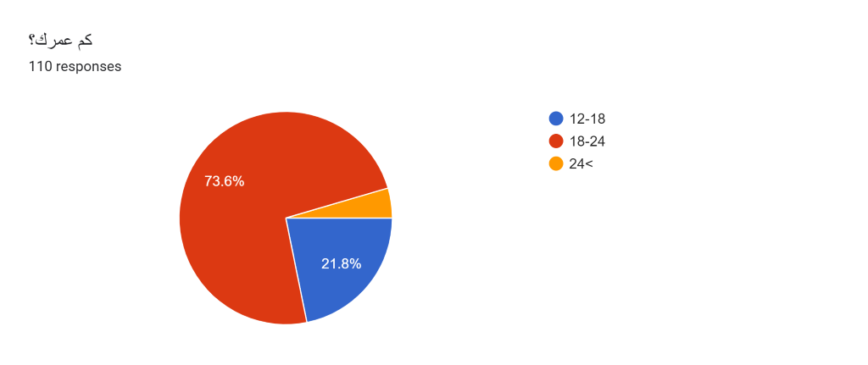

2) What's your gender?

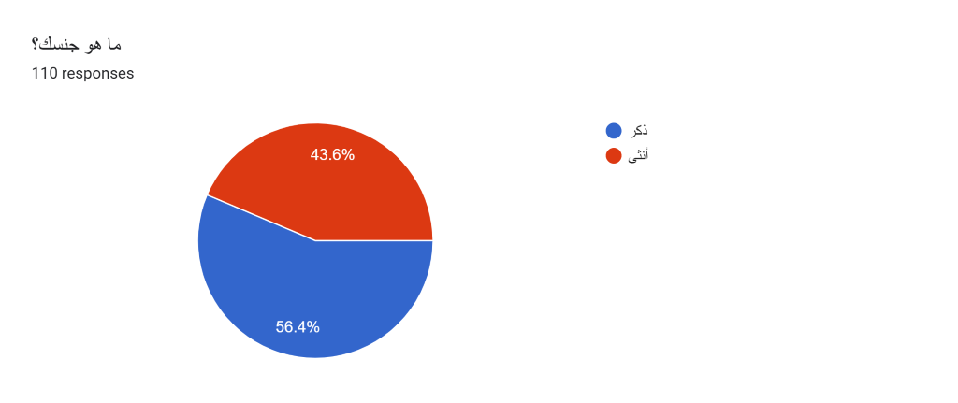

3) Are you:

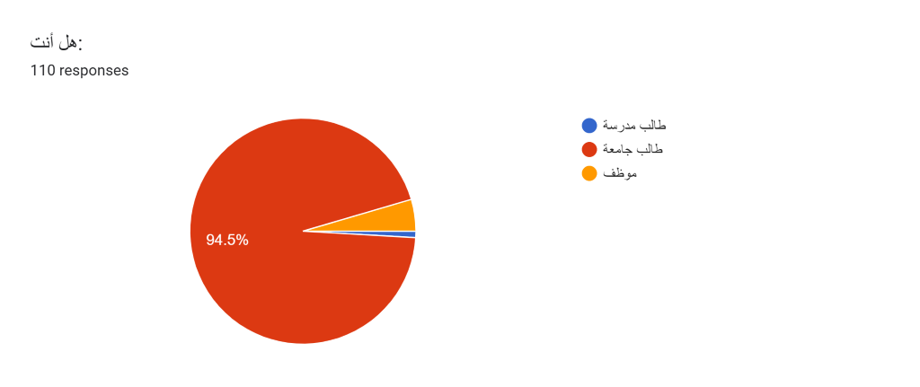

4) How do you go to school/university/work?

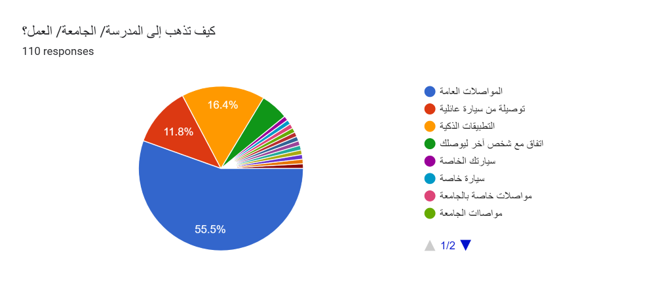

5) Out of 5, how satisfied are you with the method of transportation you use?

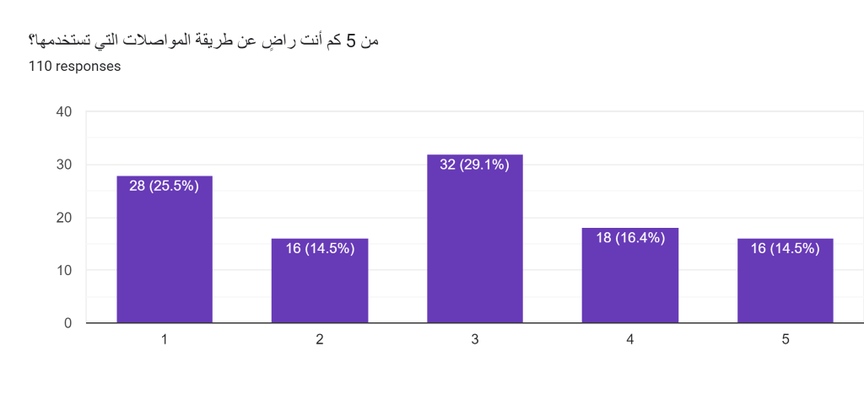

6) Does the method of transportation affect your life negatively?

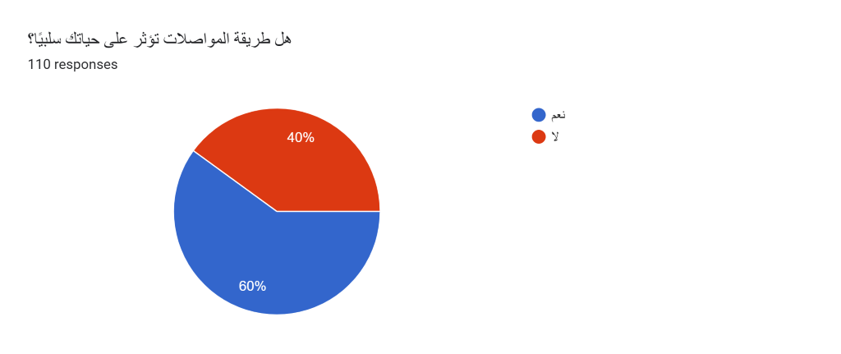

7) How does the method you use affect you positively or negatively?

1- Negatively a waste of time, Positive saving money

2- Negatively Overloading of transport vehicles

3- Wake up an hour and a half before the lecture and the university is 15-20 minutes away

8) How long does your transportation method take from your daily life? (Going and coming back)

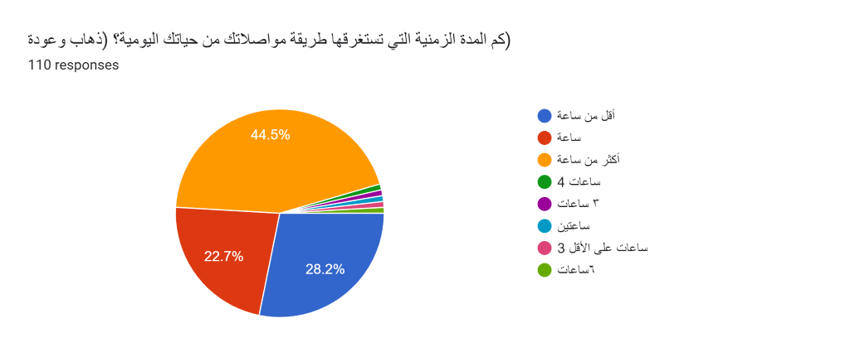

9) Do you think that public transportation is always available?

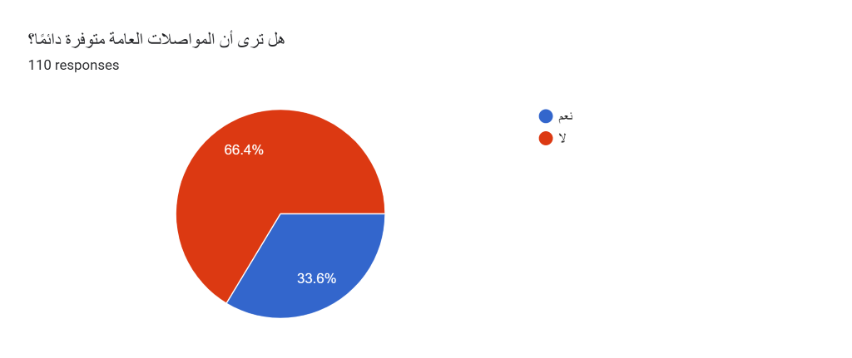

10) What are your suggestions for improving your transportation method?

1- Control of coaster buses and increasing the number of buses and setting a specific time for departure and arrival.

2- That all transportation networks be subject to the management of a dedicated body and the work of development and restructuring committees that include service, line buses, corporate buses, and Oman Vision buses, including the express bus.

3- For private cars, enlarge the university garages

11) Do you have new ways to solve transportation problems in Jordan?

1- It is the use of people's personal cars to transport other people who go to a place that corresponds to the other person's route.

2- Make an express train or increase the number of express buses

3- Establishing mandatory laws, if they are violated, those who violate them will be punished

4- Expanding streets and making bridges and tunnels

B) If a driver: -

1) How old are you?

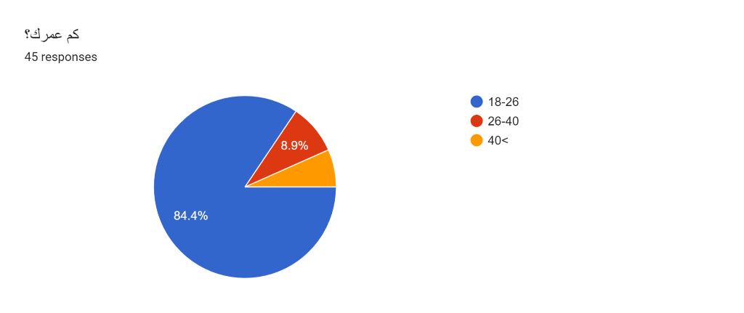

2) Do you work on public transportation vehicles and smart applications?

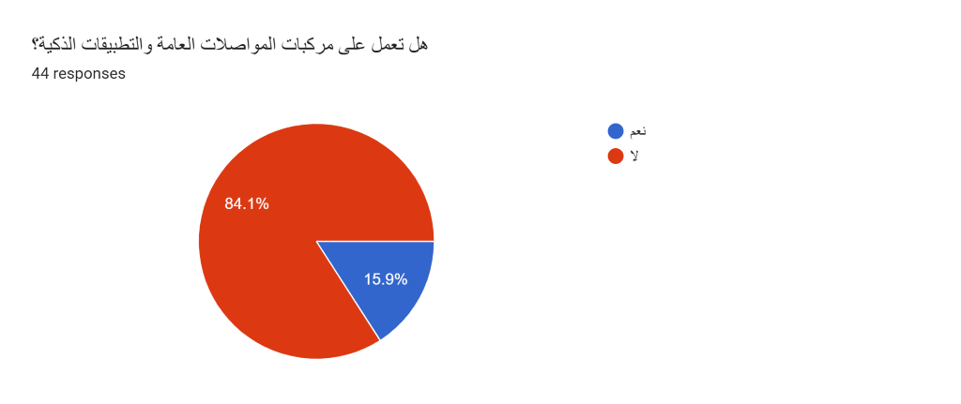

a) If A driver working on public transportation vehicles:

1) What is the means of transportation that you work on?

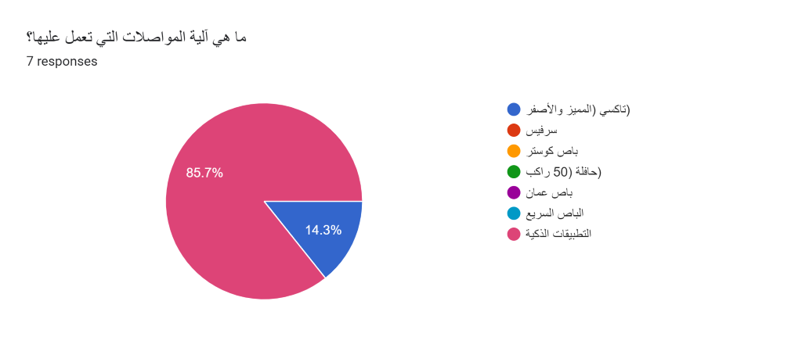

2) Is this job your main and only source of income?

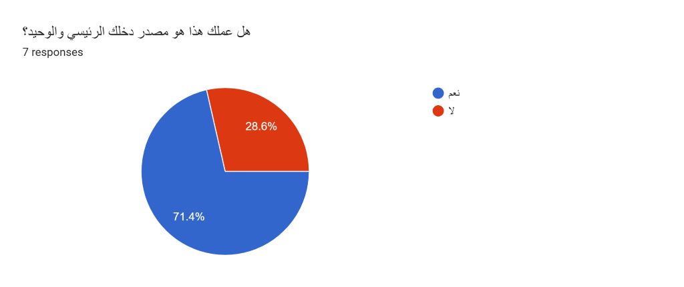

3) How satisfied are you with your work out of 5?

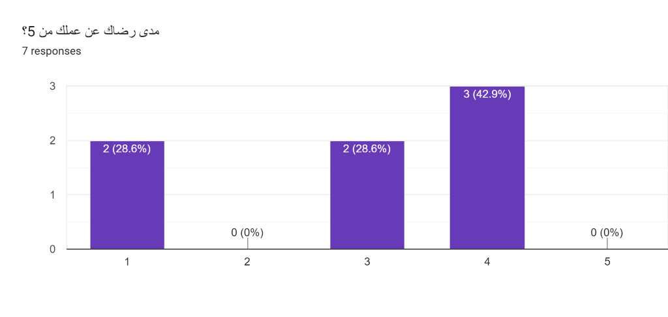

4) Do you think that the many ways of transportation is useless and not financially feasible for you?

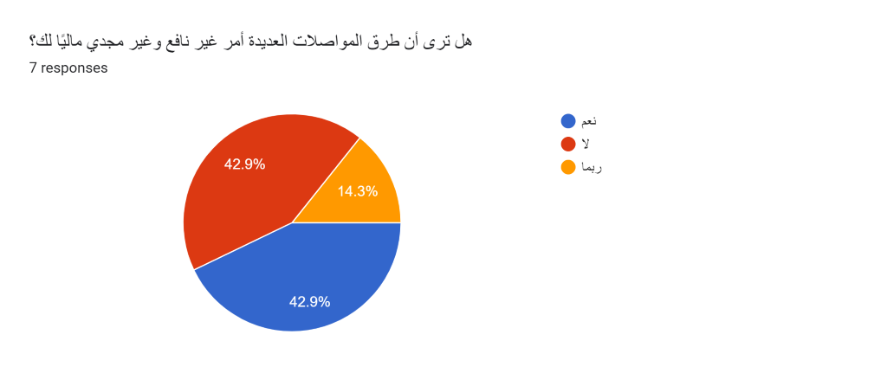

5) Are you having problems with customers?

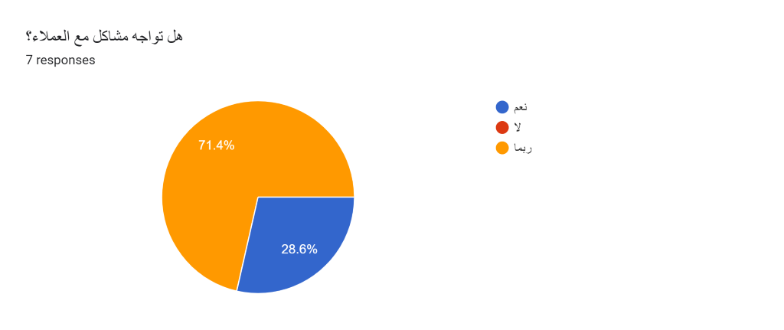

6) If your answer is yes, what are these problems?

1- Passenger ratings for the captain are bad

2- Some clients do not pay the value of the trip when they get off, saying I am going to get the money and not coming back

7) What do you think of the service you provide to passengers?

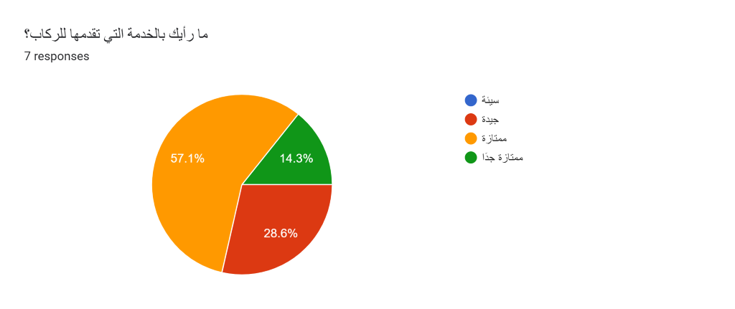

8) What problems do you face in your work?

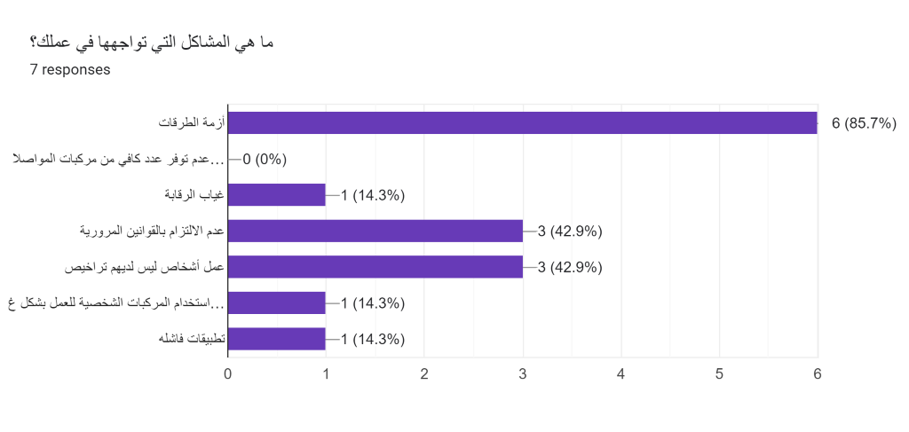

09) What do you think of the "swvl" program?

1- Bad

2- I don't know about him

b) If A driver who does not work on public transportation roads:

1) Are you:

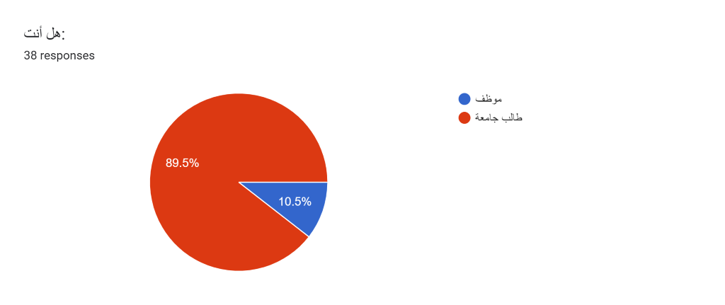

2)The car you drive is yours or is it mortgaged to the bank?

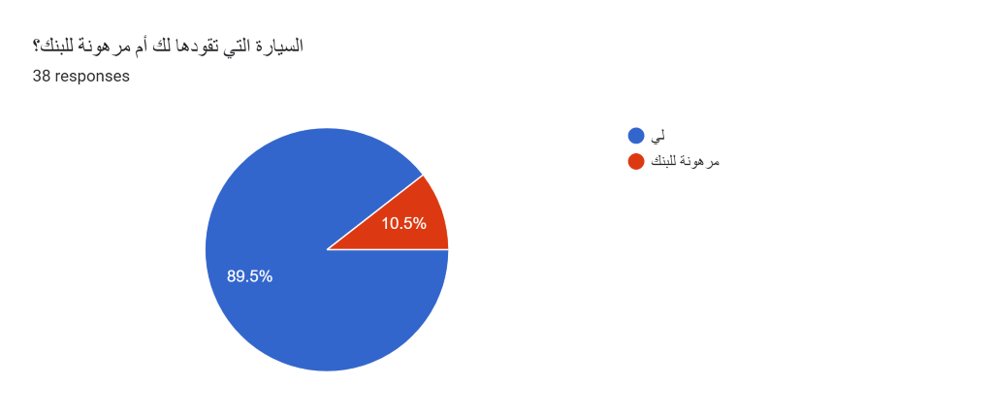

3) what is your car type?

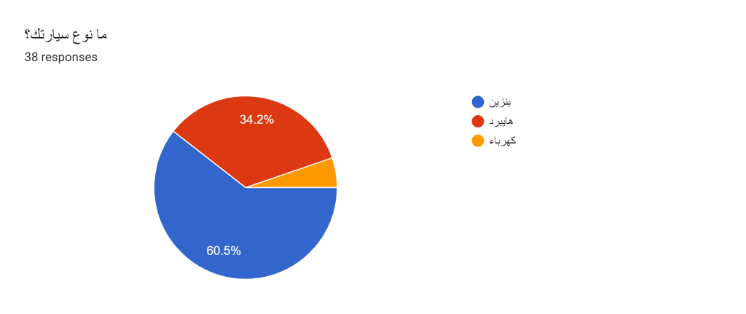

4) Do you deliver people on your way to study or work?

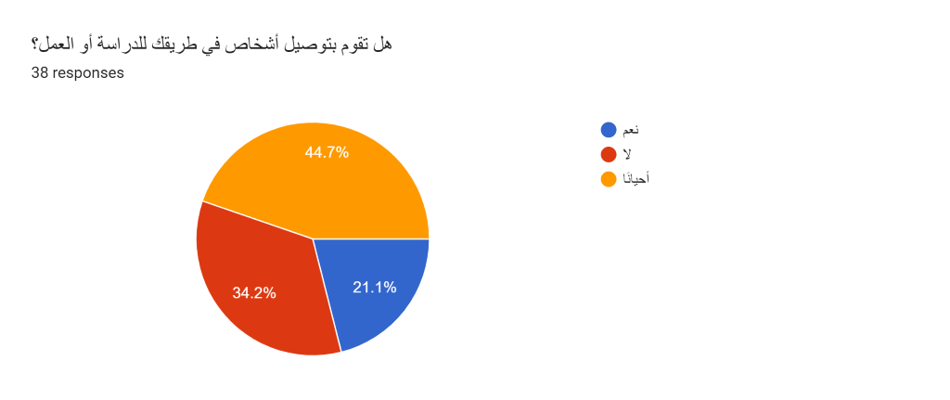

6) Do you think that reducing the number of cars reduces the road crisis?

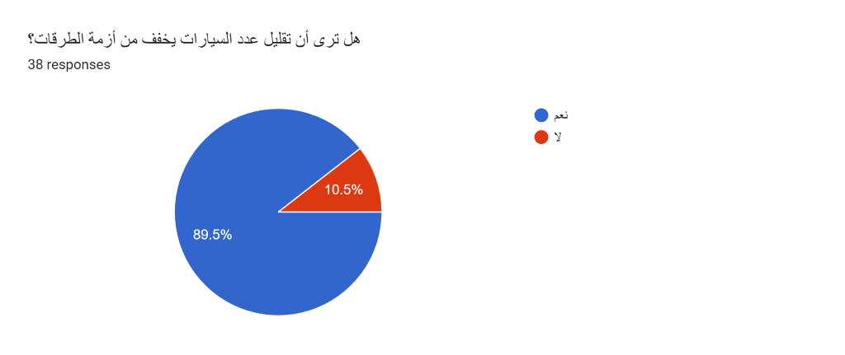

7) Would you use public transportation if it provided excellent service?

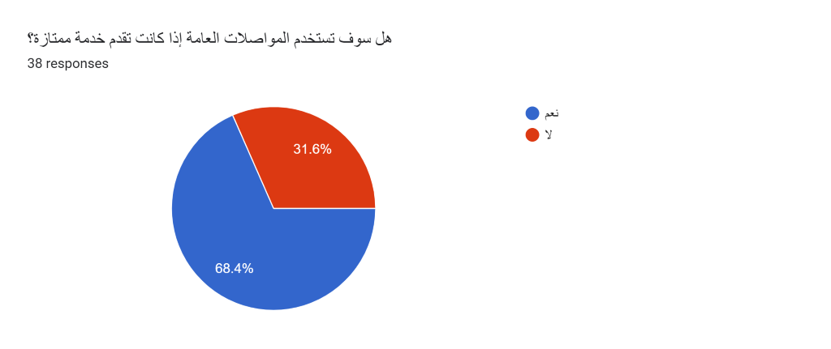

8) Are you working on your car and adding extra income?

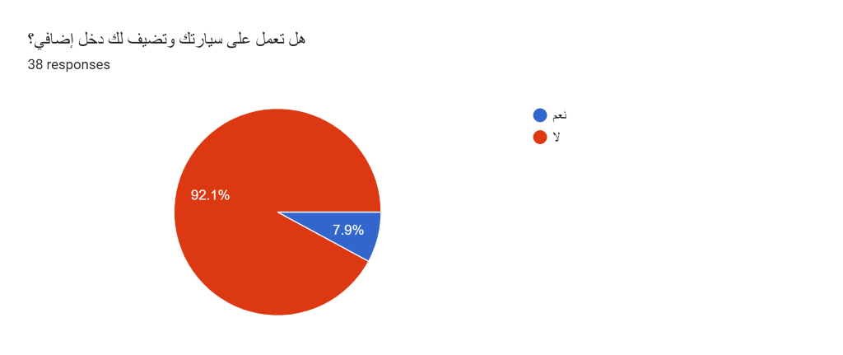

9) Do you think that people will not buy cars, especially if there is excellent public transportation?

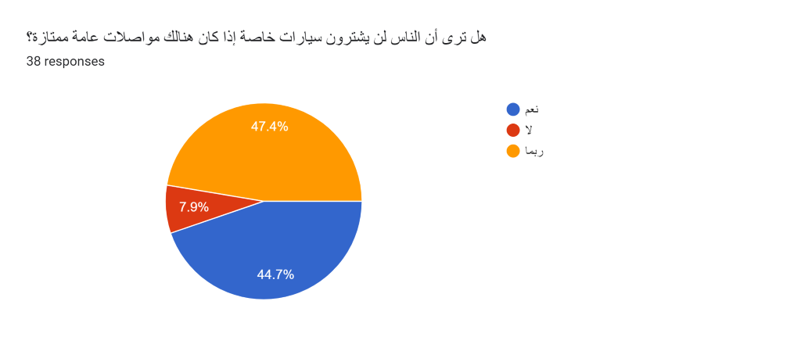

10) Do you see that you have a responsibility to reduce the traffic crisis and preserve the environment?

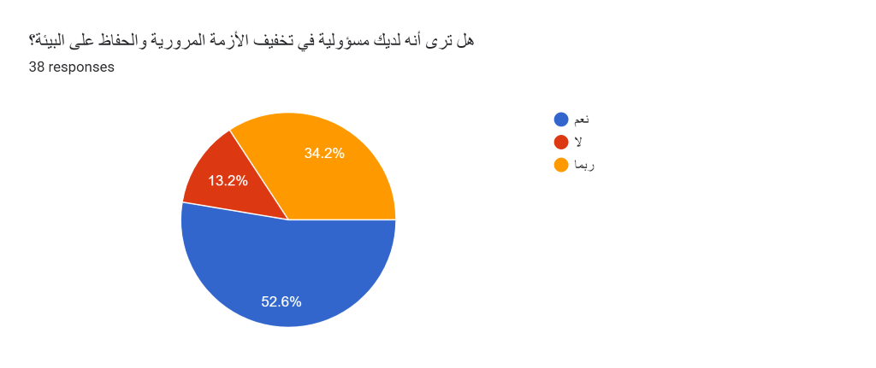

1. <https://forms.gle/Uxg15bmp3x7woMrx5>
2. <https://forms.gle/Uxg15bmp3x7woMrx5>
3. [نسبة انتشار وسائل النقل العام ضئيلة مقارنة بعدد السكان - جريدة الغد (alghad.com)](https://alghad.com/%D9%86%D8%B3%D8%A8%D8%A9-%D8%A7%D9%86%D8%AA%D8%B4%D8%A7%D8%B1-%D9%88%D8%B3%D8%A7%D8%A6%D9%84-%D8%A7%D9%84%D9%86%D9%82%D9%84-%D8%A7%D9%84%D8%B9%D8%A7%D9%85-%D8%B6%D8%A6%D9%8A%D9%84%D8%A9-%D9%85%D9%82/)
4. <https://opentransportationjournal.com/VOLUME/13/PAGE/227/>
5. <https://www.jordannews.jo/Section-106/Features/Traffic-congestion-losses-amount-to-JD1-5-billion-annually-963>
6. <https://www.7iber.com/environment-urban/analyzing-demand-on-public-transportation-in-amman/>
7. <https://forms.gle/b6MbPuFVJrCkxD7Q8>
8. <https://previewer.adalo.com/47c66a93-22b1-48ec-b1b2-1d55f941f759>
9. <https://previewer.adalo.com/62cc183d-106c-4a13-95ca-ccd28f17a4d4>
10. [Car-sharing - Worldwide | Statista Market Forecast](https://www.statista.com/outlook/mmo/shared-mobility/shared-rides/car-sharing/worldwide)
11. [Car-sharing - Worldwide | Statista Market Forecast](https://www.statista.com/outlook/mmo/shared-mobility/shared-rides/car-sharing/worldwide)
12. [Ride-hailing & Taxi - Jordan | Statista Market Forecast](https://www.statista.com/outlook/mmo/shared-mobility/shared-rides/ride-hailing-taxi/jordan)
13. [Ride-hailing & Taxi - Jordan | Statista Market Forecast](https://www.statista.com/outlook/mmo/shared-mobility/shared-rides/ride-hailing-taxi/jordan)
14. <https://forms.gle/Uxg15bmp3x7woMrx5>
15. [نسبة انتشار وسائل النقل العام ضئيلة مقارنة بعدد السكان - جريدة الغد (alghad.com)](https://alghad.com/%D9%86%D8%B3%D8%A8%D8%A9-%D8%A7%D9%86%D8%AA%D8%B4%D8%A7%D8%B1-%D9%88%D8%B3%D8%A7%D8%A6%D9%84-%D8%A7%D9%84%D9%86%D9%82%D9%84-%D8%A7%D9%84%D8%B9%D8%A7%D9%85-%D8%B6%D8%A6%D9%8A%D9%84%D8%A9-%D9%85%D9%82/)
16. [Car-sharing - Worldwide | Statista Market Forecast](https://www.statista.com/outlook/mmo/shared-mobility/shared-rides/car-sharing/worldwide)
17. [Car-sharing - Worldwide | Statista Market Forecast](https://www.statista.com/outlook/mmo/shared-mobility/shared-rides/car-sharing/worldwide)
18. <https://alghad.com/%D8%A7%D9%84%D8%AA%D8%A7%D9%83%D8%B3%D9%8A-%D8%A7%D9%84%D8%A3%D8%B5%D9%81%D8%B1-%D9%8A%D8%A8%D8%AF%D8%A3-%D8%A7%D9%84%D8%B9%D9%85%D9%84-%D9%88%D9%81%D9%82%D8%A7-%D9%84%D9%84%D8%AA%D8%B9%D8%B1/>
19. <https://ar.wikipedia.org/wiki/%D8%A7%D9%84%D8%A8%D8%A7%D8%B5_%D8%A7%D9%84%D8%B3%D8%B1%D9%8A%D8%B9_(%D8%B9%D9%85%D8%A7%D9%86)>